Fire and Security Alarm Monitoring System

1. Introduction
The Fire and Security Alarm Monitoring System (FASAM) is responsible for monitoring safety inside a large building that contains several zones. Each zone includes different types of devices such as fire detectors, security sensors, alarms, sprinklers, doors, occupancy sensors, route indicators, and electrical shutdown units.
FASAM is designed to monitor alarms continuously across all parts of the building. It also helps operators respond to incidents and aims to minimise false alarms where possible. In situations where there are no operators in the control area, the system can automatically react to serious emergencies. The system brings together fire detection, security monitoring, evacuation management, and automated emergency responses to improve safety and support building operations.
As the system has control over important building functions, it must operate in a secure and reliable way. It should also support auditing and continue working safely if faults or failures happen.
Requirements engineering and management are used throughout the development of the system to ensure that requirements can be validated and traced during the full lifecycle, in line with ISO/IEC/IEEE 29148-1:2018. Security and audit controls are also included because the system manages access to building areas and controls doors and other actions. One example of a suitable control framework is the NIST SP 800-53 catalogue.

2. Definition of Requirements and Partial Specification
Stakeholder | Interest
Building occupants | Safe evacuation procedures and clear emergency warnings
System operator | Accurate alarms, manual controls, and an easy-to-use interface
Fire services | Reliable incident confirmation and location information
Security services | Intrusion monitoring and zone isolation capabilities
Facilities manager | Maintenance support, testing, and compliance reporting
Emergency services | Automatic notification during critical incidents
System administrator | User access management and audit logging

2.1 Functional Requirements
ID | Functional Requirement
FR1 | FASAM must monitor all fire and security sensors across the building continuously.
FR2 | The system should confirm fire alarms using multiple sensor readings where possible.
FR3 | Emergency services should be contacted automatically if a serious alarm occurs while the control area is unattended.
FR4 | Evacuation alarms must activate once a fire incident has been confirmed.
FR5 | Exit direction indicators should illuminate during evacuation events.
FR6 | Sprinklers should only activate after the system checks that no occupants are present in the affected area.
FR7 | Electrical equipment in affected zones must shut down automatically when required.
FR8 | Operators must be able to manually confirm or dismiss alarms.
FR9 | The system shall isolate zones through automatic door locking during security incidents.
FR10 | All alarms and operator actions must be stored in secure audit logs.
FR11 | Internal doors should lock automatically during confirmed security incidents.
FR12 | Authorised users must be able to place selected zones into maintenance mode.
FR13 | The system must record all events in an incident log.
FR14 | Alarm status and affected zones should be displayed clearly on the operator dashboard.
FR15 | Authorised operators should be able to override automatic system responses when necessary.

2.2 Non-Functional Requirements
ID | Non-Functional Requirement
NFR1 | The system must operate continuously 24/7.
NFR2 | Alarm responses should occur within two seconds of detection.
NFR3 | The system should remain available during partial hardware failures.
NFR4 | Operator access must require secure authentication.
NFR5 | Audit logs should remain encrypted and protected from tampering.
NFR6 | The system must support future expansion for additional zones and sensors.
NFR7 | The operator interface should be simple and easy to navigate.
NFR8 | Maintenance and diagnostics should be possible without shutting down the full system.
NFR9 | FASAM must comply with relevant fire safety and security regulations.
NFR10 | Backup power support should be available during outages.

2.3 Partial Specification
The FASAM system continuously monitors fire and security sensors located throughout multiple zones of the building. If a potential incident is detected, the system analyses the sensor input to identify the severity of the event and decide on the appropriate response.
In fire-related situations, the system may trigger evacuation alarms, activate exit indicators, enable sprinkler systems, and shut down electrical equipment where necessary.
Sprinklers are only activated after occupancy checks are completed to minimise risks to occupants. For security-related incidents, the system can automatically lock internal doors and isolate affected areas to stop unauthorised movement inside the building.
Both automatic and manual responses are supported by the system. Authorised operators are able to confirm alarms, dismiss false alarms, manually notify emergency services, isolate building zones, and review incident records using the operator interface. All system events, alarms, and operator activities are stored in an audit log for traceability, maintenance, and compliance purposes.

3. Outline Architectural Design Using UML Modelling Technique

3.1 Fire Services Use Case Diagram
The Fire Services Use Case Diagram illustrates the way the FASAM system responds to fire-related incidents inside the building. It demonstrates how fire sensors, emergency services, and the system’s automated safety features interact with each other.
The diagram also outlines the confirmation process required before evacuation alerts, sprinkler systems, and electrical shutdown actions are activated.
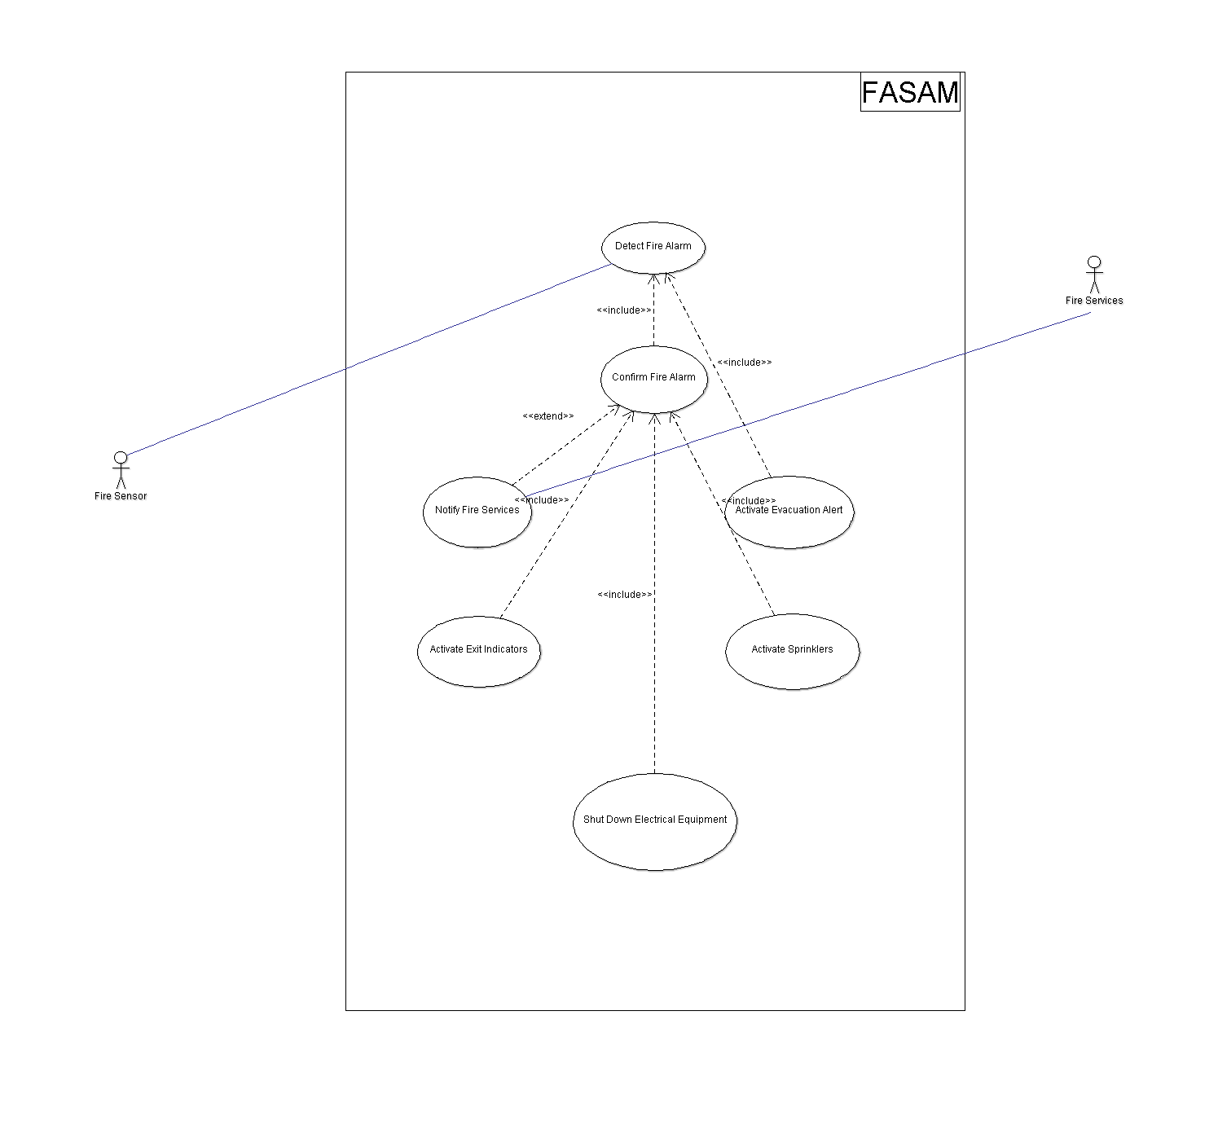
Figure 1: Fire Services Use Case Diagram

3.2 Security Services Use Case Diagram
The Security Services Use Case Diagram describes how the FASAM system handles security-related events throughout the building. The diagram highlights the interaction between security sensors, security personnel, and automated security responses such as locking doors and isolating affected zones.
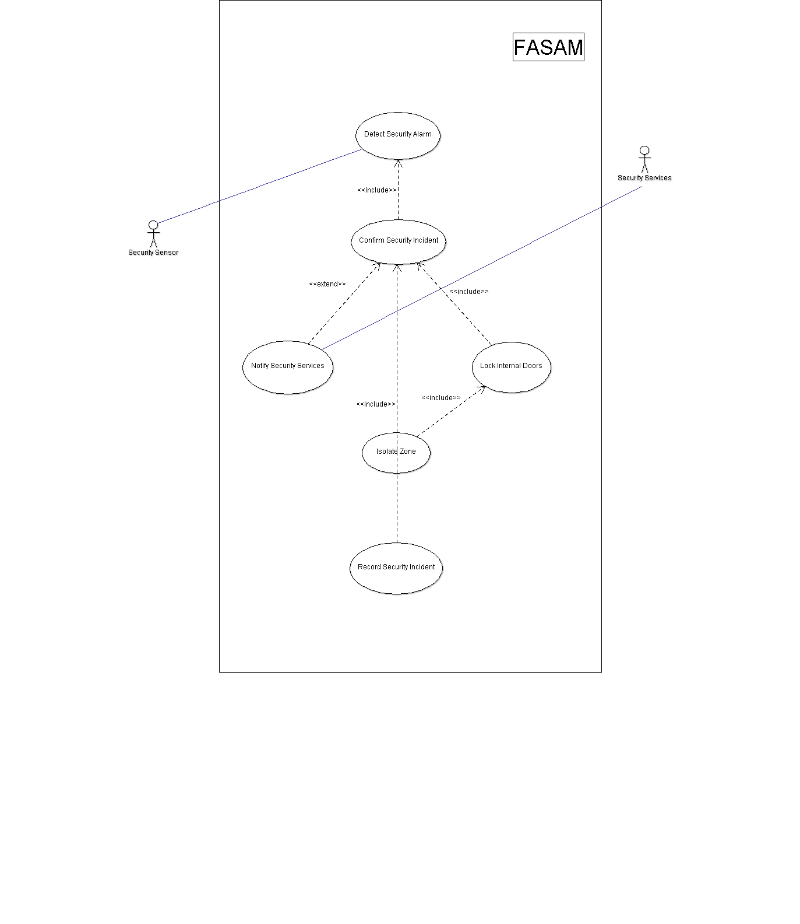

Figure 2: Security Services Use Case Diagram

3.3 System Operator – Manual Use Case Diagram
The System Operator Manual Use Case Diagram demonstrates the manual interactions available to authorised operators within the FASAM system. The diagram highlights operational controls such as alarm confirmation, false alarm rejection, manual escalation procedures, maintenance management, and incident log review capabilities.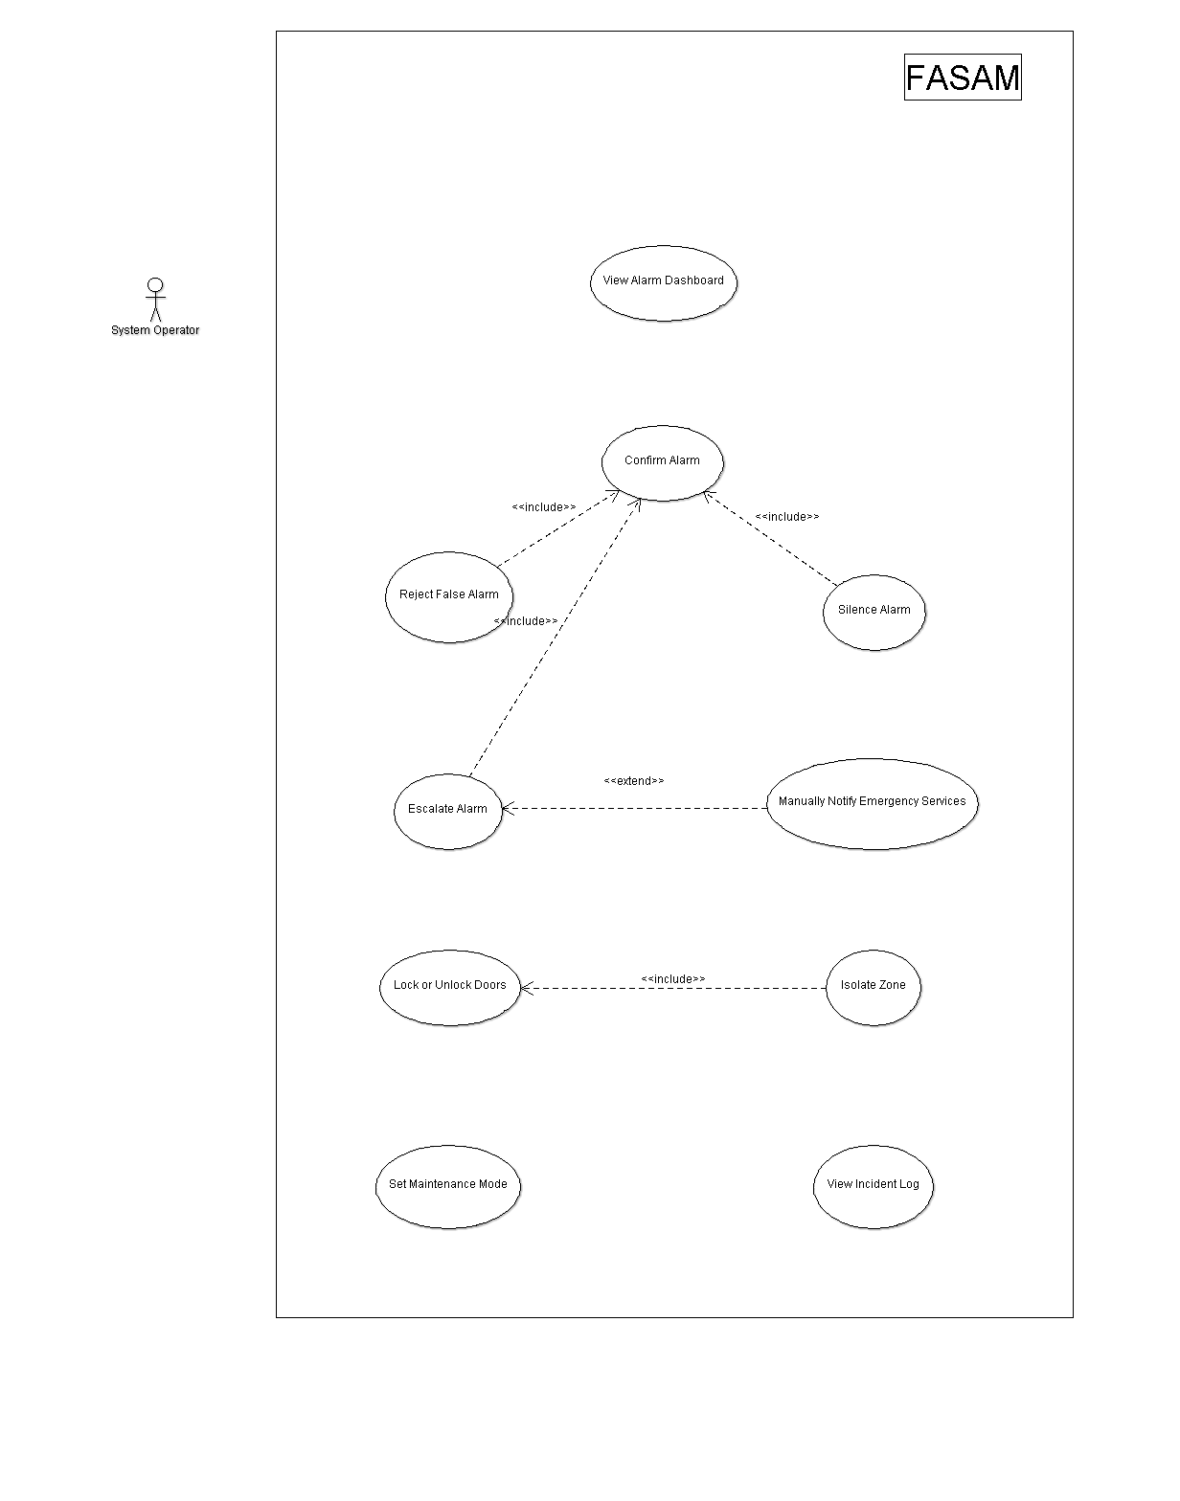

Figure 3: System Operator – Manual Use Case Diagram

3.4 System Response – Automatic Use Case Diagram
The System Response Automatic Use Case Diagram represents the automated functions of the FASAM system during emergencies. The diagram highlights how the system monitors sensors, analyses alarm severity, initiates emergency procedures, and controls safety mechanisms automatically without direct operator intervention.
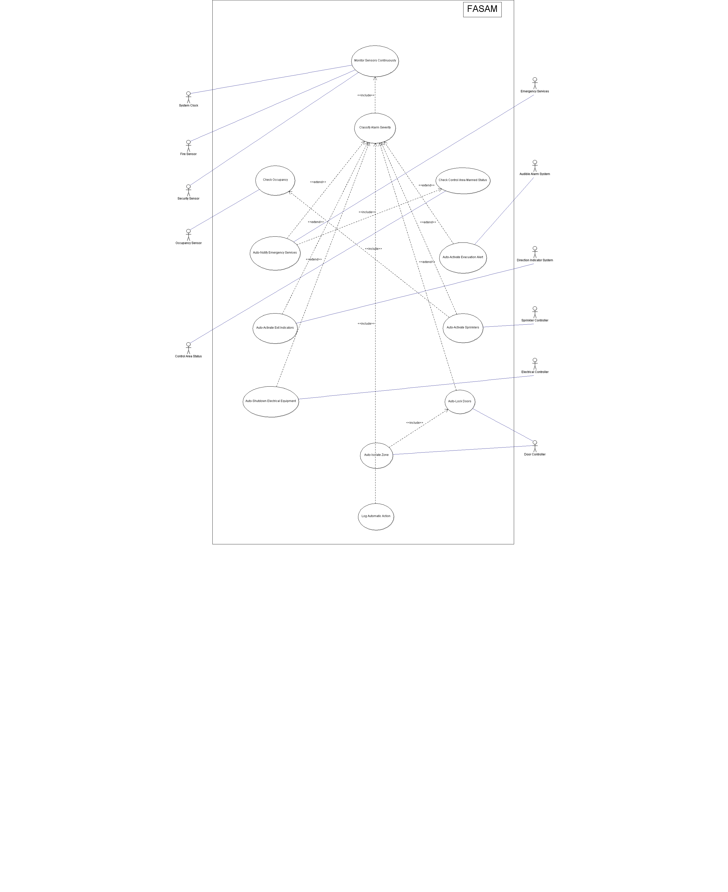
Figure 4: System Response – Automatic Use Case Diagram

3.5 Consolidated Use Case Diagram
The Consolidated Use Case Diagram presents the fire services, security services, operator activities, and automatic response functions within a single integrated model. It gives a complete overview of the FASAM system architecture and demonstrates how different components work together to support security, safety, and operational management functions.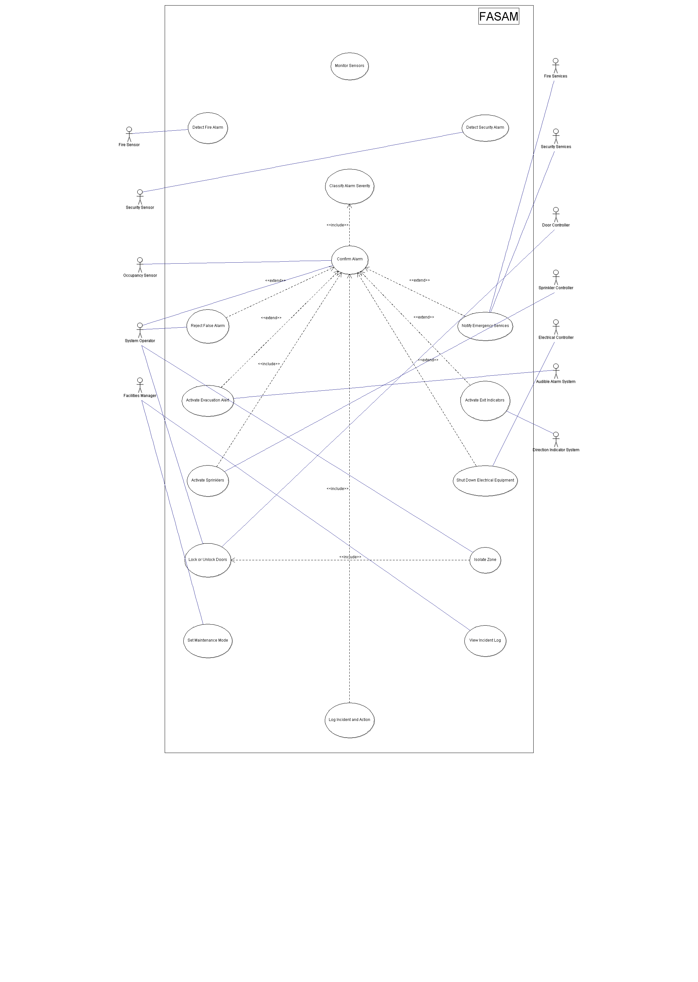
Figure 5: Consolidated Use Case Diagram

3.6 Use Case Descriptions

3.6.1 UC1 – Detect Fire Alarm
Field | Description
Use Case ID | UC1
Primary Actor | Fire Sensor
Use Case Name | Detect Fire Alarm
Goal | Detect signs of a possible fire within a building zone
Preconditions | Fire sensors are connected and functioning correctly
Main Flow | The sensor detects smoke, heat, or flames and sends an alert to FASAM.
Alternative Flow | A sensor fault or communication error is detected instead.
Postconditions | The alarm is logged and displayed for confirmation

3.6.2 UC2 – Detect Security Alarm
Field | Description
Use Case ID | UC2
Use Case Name | Detect Security Alarm
Primary Actor | Security Sensor
Goal | Detect unauthorised access or suspicious activity.
Preconditions | Security sensors are active and operational
Main Flow | Motion, forced entry, or unusual activity is detected and reported
Alternative Flow | Sensor communication failure occurs
Postconditions | The incident is logged and displayed to operators.

3.6.3 UC3 – Confirm Alarm
Field | Description
Use Case ID | UC3
Use Case Name | Confirm Alarm
Primary Actor | System Operator / FASAM
Goal | Verify whether an alarm is genuine before escalation.
Preconditions | An alarm has been detected and recorded.
Main Flow | The system analyses multiple sensor inputs or the operator manually confirms the alarm.
Alternative Flow | The operator rejects the alarm as false.
Postconditions | The alarm status changes to confirmed and emergency procedures may begin.

3.6.4 UC4 – Notify Emergency Services
Field | Description
Use Case ID | UC4
Use Case Name | Notify Emergency Services
Primary Actor | FASAM / System Operator
Goal | Alert emergency services during serious incidents.
Preconditions | A critical alarm has been confirmed.
Main Flow | The system automatically contacts emergency services and provides location and incident details.
Alternative Flow | The operator manually contacts emergency services.
Postconditions | Emergency services are informed and the notification is logged.

3.6.5 UC5 – Activate Evacuation Alert
Field | Description
Use Case ID | UC5
Use Case Name | Activate Evacuation Alert
Primary Actor | FASAM
Goal | Warn occupants to evacuate the building safely.
Preconditions | A fire alarm has been confirmed.
Main Flow | Audible alarms are activated throughout affected zones.
Alternative Flow | Alarm hardware failure is detected.
Postconditions | Occupants are alerted to evacuate.

3.6.6 UC6 – Activate Sprinklers
Field | Description
Use Case ID | UC6
Use Case Name | Activate Sprinklers
Primary Actor | FASAM
Goal | Suppress confirmed fire incidents automatically.
Preconditions | Fire alarm confirmed and occupancy check completed.
Main Flow | The system activates sprinklers in the affected area.
Alternative Flow | Occupancy detected, preventing sprinkler activation.
Postconditions | Sprinklers activate and the action is logged.

3.6.7 UC7 – Lock or Unlock Doors
Field | Description
Use Case ID | UC7
Use Case Name | Lock or Unlock Doors
Primary Actor | FASAM
Goal | Control building access during security incidents.
Preconditions | Door controllers are operational.
Main Flow | The system or operator sends lock or unlock commands to controlled doors.
Alternative Flow | Door controller communication failure occurs.
Postconditions | Door states are updated and recorded.

3.6.8 UC8 – Isolate Zone
Field | Description
Use Case ID | UC8
Use Case Name | Isolate Zone
Primary Actor | FASAM
Goal | Restrict access to an affected building zone.
Preconditions | A confirmed security incident exists.
Main Flow | Controlled doors within the zone are locked automatically.
Alternative Flow | Emergency override unlocks evacuation exits.
Postconditions | The affected zone becomes isolated.

3.6.9 UC9 – Reject False Alarm
Field | Description
Use Case ID | UC9
Use Case Name | Reject False Alarm
Primary Actor | System Operator
Goal | Prevent unnecessary emergency escalation.
Preconditions | Alarm is pending confirmation.
Main Flow | The operator reviews alarm details and marks the alarm as false.
Alternative Flow | Additional evidence confirms the alarm instead.
Postconditions | The false alarm is recorded and closed.

3.6.10 UC10 – View Incident Log
Field | Description
Use Case ID | UC10
Use Case Name | View Incident Log
Primary Actor | System Operator / Facilities Manager
Goal | Review historical alarms and system activity.
Preconditions | User authentication successful.
Main Flow | The user searches and filters incident records through the dashboard.
Alternative Flow | Access denied due to insufficient permissions.
Postconditions | Relevant incident records are displayed.

4. Basic Prototype for the Proposed User Interface

4.1 Main Monitoring Dashboard
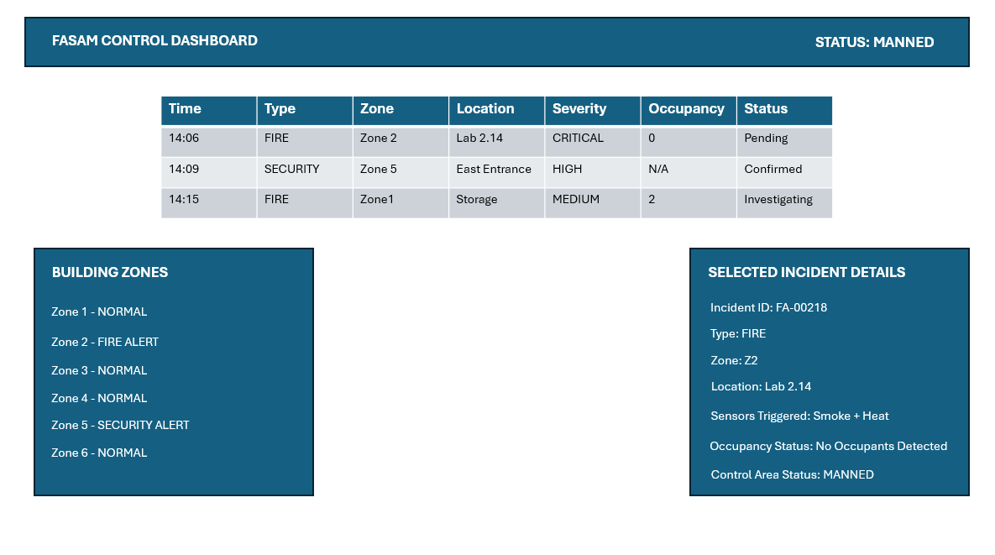
The Main Monitoring Dashboard prototype gives operators a live overview of fire and security incidents across the building. The interface shows active alarms, incident severity levels, occupancy details, affected areas, and system status indicators to help staff respond quickly during emergencies.
The dashboard was designed to be simple and easy to use in high-pressure situations. Operators can quickly identify important incidents, check alarm information, monitor automatic system responses, and manually control emergency actions when needed. The prototype also shows how the FASAM system combines real-time monitoring, operator interaction, and automated emergency management into one interface.

Figure 6: Main Monitoring Dashboard Prototype

4.2 Automatic Response Interface
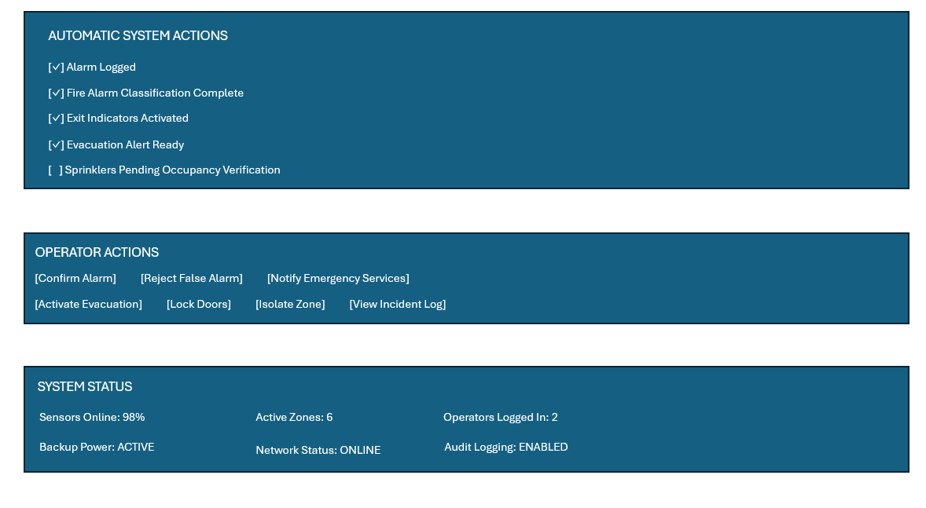
The Automatic Response Interface prototype demonstrates the automated emergency procedures performed by the FASAM system following confirmed incidents. The interface displays automated safety actions, evacuation readiness, occupancy-dependent checks, operator controls, and overall system status information.
The prototype illustrates how the system automatically performs emergency procedures such as alarm logging, evacuation alert activation, emergency notification preparation, and occupancy verification before sprinkler activation. The interface also demonstrates operator override capabilities, ensuring that authorised personnel retain manual control where necessary during critical incidents. The interface was designed to minimise operator workload during emergencies while maintaining clear visibility of all automated actions performed by the system.

Figure 7: Automatic Response Interface Prototype

5. Requirements Validation and Management Strategy

5.1 Requirements Validation
Requirements validation is used to make sure the FASAM system requirements meet stakeholder needs and safety expectations. Validation is important to confirm that the system can properly support fire detection, security management, automated emergency responses, and operator interaction.
The following validation methods will be used during the development process:
- Requirements review with stakeholders, operators, fire services, and security staff.
- UML model validation to check that use cases correctly represent system behaviour.
- Prototype testing to evaluate usability and workflow efficiency.
- Scenario-based testing using simulated fire and security incidents.
- Consistency and traceability checks between requirements, use cases, and prototypes.
- Safety and compliance checks against fire safety and security standards.

These validation activities will help ensure that false alarms, emergency escalation procedures, occupancy checks, and automated safety responses work correctly before the system is deployed.

5.2 Requirements Management Strategy
Requirements management will be used throughout the development of the FASAM system to ensure all requirements stay organised, traceable, and consistent.
Each requirement will have a unique identifier to support traceability between requirements, UML diagrams, prototypes, testing activities, and future implementation stages. This helps improve system maintenance and ensures that every system feature can be linked back to stakeholder and operational needs.
Any changes to requirements will go through formal change management procedures to reduce risks to system safety and reliability. All updates will be documented using version-controlled repositories to maintain project accuracy and traceability.
GitHub will be used to manage project documents, UML diagrams, prototypes, and version history. This supports collaboration, auditing, and recovery of earlier project versions if needed.
Traceability matrices will also be maintained to ensure that all functional and non-functional requirements are included in system models, interface prototypes, and validation activities. This helps maintain consistency between requirements engineering, system design, and validation throughout the project.

6. Conclusion
The FASAM system was developed as a complete solution for monitoring fire and security across a large building with multiple zones. It brings together automatic emergency actions, operator controls, alarm verification processes, and critical safety controls to enhance building safety, improve emergency response times, and ensure reliable operation. This project also demonstrated the use of requirements engineering, UML-based system design, interface prototyping, and validation techniques in the development of a large-scale, safety-critical software system.

7. References
- ISO/IEC/IEEE 29148:2018. Systems and Software Engineering — Life Cycle Processes — Requirements Engineering.
- National Institute of Standards and Technology (NIST). SP 800-53 Security and Privacy Controls for Information Systems and Organizations.
- Sommerville, I. (2016). Software Engineering. 10th Edition. Pearson Education Limited.
- Dennis, A., Wixom, B.H. and Tegarden, D. (2020). Systems Analysis and Design: An Object-Oriented Approach with UML. 6th Edition. Wiley.
- Object Management Group (OMG). (2023). Unified Modeling Language (UML) Specification.

